Lab Partner(s): _____________________________________________________________________

PHY 1048L Physics Laboratory I

Lab5: Forces and Vectors

Part 1: Balancing Forces

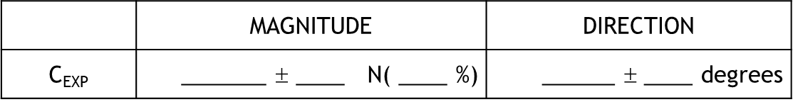

(i) Drawing Vectors
Sketch $\vec{A}$, $\vec{B}$, and $\vec{C}$ , on the figures below to include their components. Depict only one vector on each figure.

(ii) Calculations
Calculate the magnitude and direction of $\vec{C}$ (${\vec{C}}_{CAL}$) using the formulas,
$\left|C\right|=\sqrt{C_{x}^{2}+C_{y}^{2}}$ , $Ø=\tan^{-1}\left(\frac{C_{y}}{C_{x}}\right)$ where $C_{x} = -A_{x}-B_{x}$and
$C_{y}={-A}_{y}-B_{y}$. Enter the values in the Vector Table (see Next Page).
Next enter the your experimentally measured magnitude and direction
of ${\vec{C}}_{EXP}$ from step 3 and calculate % Difference ( $=\frac{\left|C_{CAL}-C_{EXP}\right|}{\frac{1}{2}\left(C_{CAL}+C_{EXP}\right)}×100$ )
between ${\vec{C}}_{CAL}$and ${\vec{C}}_{EXP}$ vectors.

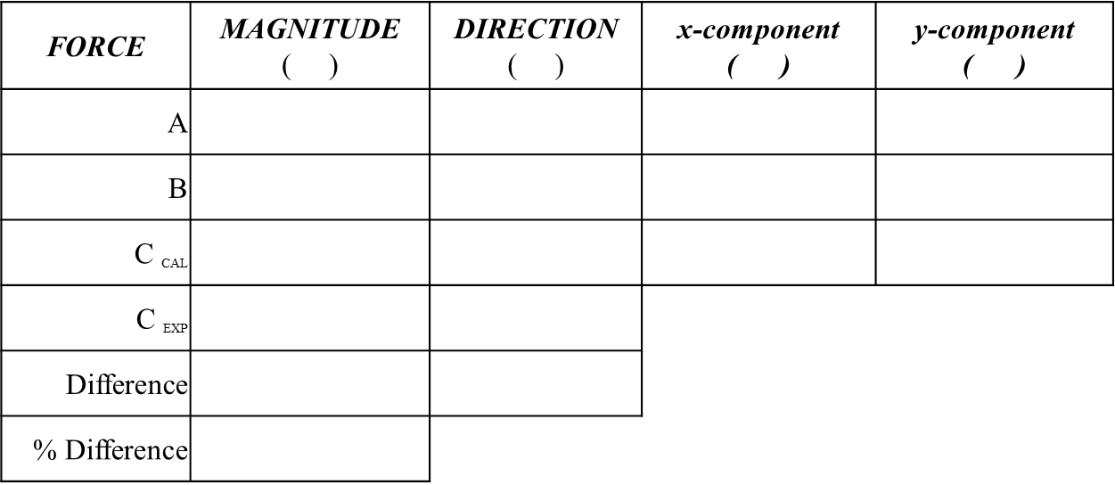

Show how ${\vec{C}}_{CAL}$ and % Difference were determined:

Part 2: Balancing Different Forces

Table 1-- Magnitude and Direction
 | MAGNITUDE | DIRECTION
C_{EXP} | _______ ± ____ N( ____ %) | ______ ± ____ degrees

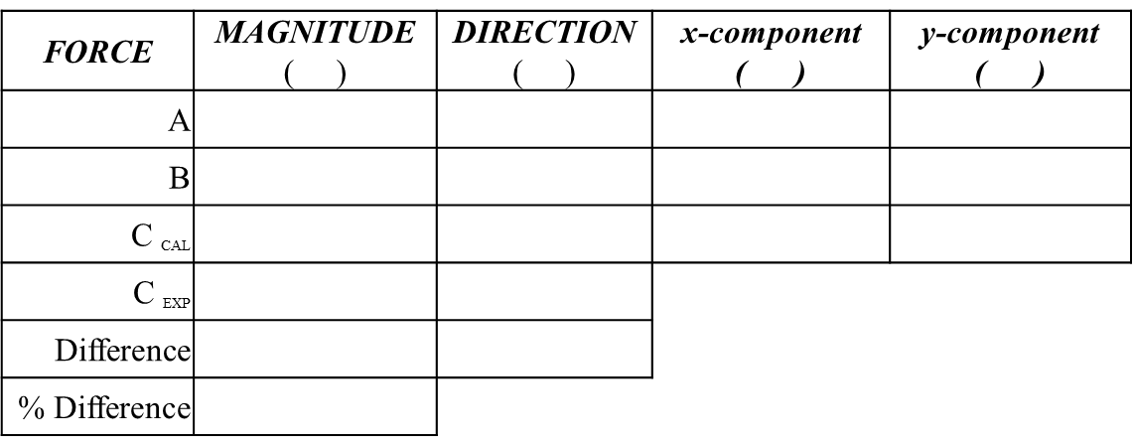

Summary and Analysis Questions

1. Even if your experimental numbers exactly matched the calculated ones, there was still error.
Describe each potential error source (listed below), and classify it as random or systematic.
- Are the pulleys a source of error? How?

- What would an improperly leveled table do to your results?

2. Explain what you learned from the parametric analysis.

3. Check calculations using a Spread Sheet

